**Page68,1 Word processing features**

**A. In pairs,discuss these questions**

1. What is a word processor?

2. What kind of tasks do people use word processors for?

3. How many different word processing programs can you name? Whitch dou you think is the most popular?

**B. Look at this screenshot from Microsoft Word and translate the labelled features and functions into your own language.**

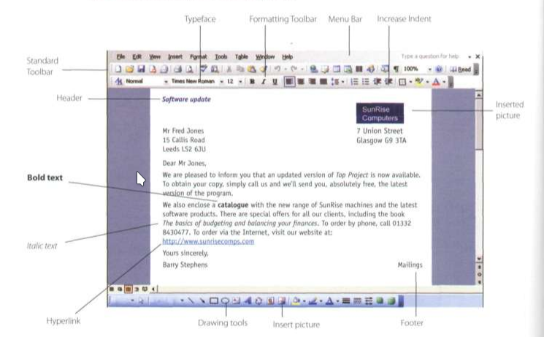

Typeface: tipo de letra

Formatting Toolbar: Barra de herramienta de formato

Menu Bar: Barra de menú

Increase Indent:Incrementar sangria

Standard Toolbar:Barra de herramientas estandar.

Header: Encabezamiento

Insert picture: Insertar imagen.

Bold text:Texto negrita

Italic text: Texto cursiva

Hiperlink: Hiperenlace

Drawing tools: Herramientas de dibujo.

Insert picture: Insertar imagen

Footer: Pie de pagina.

**C. Complete these sentences with the correct features and functions above.**

1. The Standard toolbar lists the icons to save or print a document, spell check, etc. The Formatting Toolbar is the area for changing font, alignment, indentation, etc.
2. A font consists of three elements: typeface, type style and type size. For example, Palatino bold at 10 points.
3. Type style refers to a visual characteristic of a typeface, for example B for bold , I for italic and U for underlined.
4. If you need to change indentation - the space between the page argin and where the text aligns - you can click the Increase or Decrease indent buttons.
5. The header and footer commands allow you to specify customized texts at the top and bottom of every page.

**Page69. Ex.2** **Word Sudoku**

**In pairs, read the instructions and complete the puzzle.**

Instructions

This Word Sudoku is a variation on the normal Suoku. Instead of using the numbers 1 to 9, we are using words and icons. There are nine WP functions and their equivalent icons, so we are playing with nine pairs. In order to complete the grid, you can use each function or the equivalent Icon only once In each row, each column, and in each of the 3x3 boxes. The Icons can only be used In the coloured boxes.

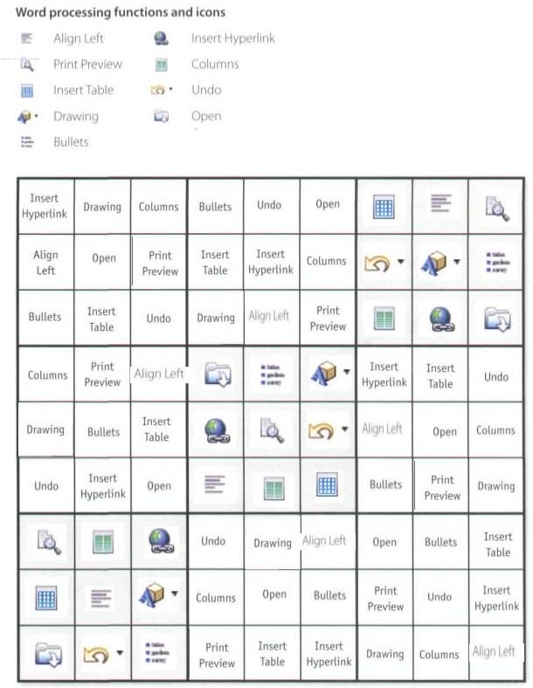

**Page70.Ex3.The Cut and Paste technique**

**A.Listen to two friends, Anna and Ben, talking about how to move text in Word. How many steps are involved in carrying out the Cut and Paste task?**

Four

**B.Listen again and complete the dialogue.**

Anna:

Ben. do you know how I can move this paragraph? I want to put It at the end of this page.

Ben: Er ... I think so. (1) First, use the mouse to select the text you want to move. (2) Then choose the Cut command from the Edit menu,

Anna: (3) Like this?

Ben: Yes. The selected text disappears and goes onto the clipboard.

(4) Now you find where you want the text to appear and you click to position the insertion point there.

Anna: Mm, OK. Is that (5)right

Ben:

Yes, if that's where you want it. (6) Next choose Paste from the Edit menu, or hold down Ctrl and press V. (7) Finally, check that the text has appeared in the right place. b,

Anna:

OK, I've (8)done that now . Is that (9) everything

Ben: Yes, that's it. If you make a mistake, you can choose Undo from the Edit menu, which will reverse your last editing command. Anna: Brilliant! Thanks a lot.

Ben: That's OK, it's my pleasure.

**Page71,4. Language work: giving and following instructions**

**A. Look at the HELP box and then correct six mistakes in this dialogue.**

A: I need a photo for my curriculum vitae.How do I insert is Word document?

B: Well,first choose insert on the Menu bar.

A: Like this?

B: Yes. From the Insert menu, select Picture. As you can see, this displays a drop-down menu with

different options: Clip Art, From File, From Scanner, Chart, etc. Select From File and you'll get a dialog box.

A: OK. I've done that now. What next?

B: OK. Now you navigate your hard drive's contents and find

the picture that you want to insert.

A: Right. I'd like to include this one.

B: OK, good. Now click Insert and the photograph will be

inserted into your document.

A: Here it is. Is that right?

B: Yes. Finally, right-click with the mouse and select Format

Picture to adjust the size and other properties.

A: Brilliant, thanks!

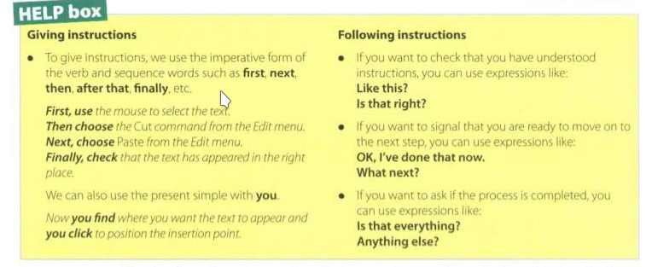

**B. Complete these instructions for how to Copy and Paste in Word with verbs from the box.**

|  |
| --- |
| click(x2) select position right-click drag |

1. First,select the text you wish to copy. To select text, drag the mouse over the portion of the text that you want to copy. This part should then be highlighted.
2. Then click on the Copy Icon on the Standard Toolbar. This copies the selected text to an invisible clipboard.
3. Next, position the cursor where you want the text to appear.
4. Finally, click the Paste icon. This inserts the content of the clipboard at the insertion point. As well as the Icons on the toolbar, you can use the keys *Ctrl+C* for *Copy*, and *Ctrl+V* for *Paste.* These options also come up if you right-click the selected text.

**Page 72, 5. WP tools**

**A Scan the descriptions of three WP tools (1-3) - a spell checker, an online thesaurus and a grammar checker - and match them with the dialog boxes (a-c).**

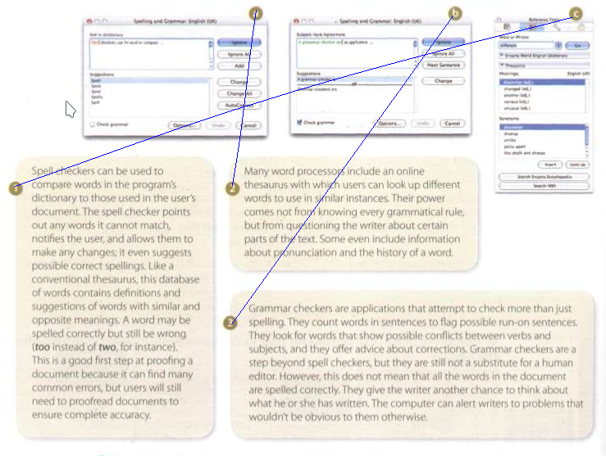

**B.Read the descriptions more carefully. Find three sentences that have been printed in the wrong text and decide where they should go.**

1. Spell checkers can be used to compare words in the program's dictionary to those used in the user's document The spell checker points out any words it cannot match. notifies the user, and allows them to make any changes: it even suggests possible correct spellings. However,this does not mean that all the words in the document are spelled correctly. ~~Like a conventional thesaurus, this database of words contains definitions and suggestions of words with similar and opposite meanings.~~ A word may be spelled correctly but still be wrong (too instead of two, for instance). This is a good first step at proofing a document because it can find many common errors, but users will still need to proofread documents to ensure complete accuracy.
2. Many word processors include an online thesaurus with which users can look up different words to use in similar instances. Like a conventional thesaurus,this database of words contains definitions and suggestions of words with similar and opposite meanings. ~~Their power comes not from knowing every grammatical rule, but from guesning the writer about certain parts of the text.~~ Some even include information about pronunciation and the history of a word.
3. Grammar checkers are applications that attempt to check more than lust spelling They count words in sentences to flag possible run-on sentences. They look for words that show possible conflicts between verbs and subjects, and they offer advice about corrections. Grammar checkers are a step beyond spell checkers, but they are still not a substitute for a human editor. Their power comes not from knowing every grammatical rule, but from questioning the whiter about certain parts of the text ~~However. this does not mean that all the words in the document are spelled correctly~~. They give the writer a chance to think about what he or she has written. The computer can alert writers to problems that wouldn't be obvious to them otherwise.

**C Correct the three mistakes in this sentence and decide if they would be found by the spell checker or the grammar checker.**

Mail merge combines a form letter with a database file to create customized copies of the letter.

The grammar checker would find the first mistake, the spell checker the second and third.